Review Exercises: 1-6 all

- A combinational circuit is a circuit in which the output is uniquely defined for every combination of inputs

- A sequential circuit is a circuit in which the output is a function of the input and the state of the system.

- An And gate produces a 1 only when both inputs are 1, otherwise the output is a 0.

- An Or gate produces a 0 only when both inputs are 0, otherwise the output is a 1.

- A Not gate receives a single input and produces the opposite output.

- An inverter is a Not gate

Exercises: 1-9 all

1 2
x₁ x₂ 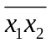 x₁ x₂ 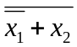
0 0 1 0 0 0
0 1 1 0 1 0
1 0 1 1 0 1
1 1 0 1 1 0

3 4
x₁ x₂ x₃ 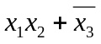 x₁ x₂ x₃ 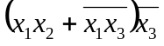
0 0 0 1 0 0 0 1
0 0 1 0 0 0 1 0
0 1 0 1 0 1 0 1
0 1 1 0 0 1 1 0
1 0 0 1 1 0 0 1
1 0 1 0 1 0 1 0
1 1 0 1 1 1 0 1
1 1 1 1 1 1 1 0

5
x₁ x₂ x₃ x₄ 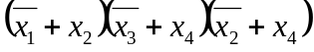 = 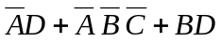
0 0 0 0 1
0 0 0 1 1
0 0 1 0 0
0 0 1 1 1
0 1 0 0 0
0 1 0 1 1
0 1 1 0 0
0 1 1 1 1
1 0 0 0 0
1 0 0 1 0
1 0 1 0 0
1 0 1 1 0
1 1 0 0 0
1 1 0 1 1
1 1 1 0 0
1 1 1 1 1

6
x₁ x₂ x₃ x₄ 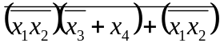 = 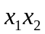
0 0 0 0 0
0 0 0 1 0
0 0 1 0 0
0 0 1 1 0
0 1 0 0 0
0 1 0 1 0
0 1 1 0 0
0 1 1 1 0
1 0 0 0 0
1 0 0 1 0
1 0 1 0 0
1 0 1 1 0
1 1 0 0 1
1 1 0 1 1
1 1 1 0 1
1 1 1 1 1

- if x = 1, then y depends on current value of y. y becomes opposite of current value

- if x = 0, then y is always 1, since 0 and y is 0, and not 0 = 1

- See # 7. When x = 1, y has different values depending on current value of y.

